//program for synchronous multiplier

#include<stdio.h>

#include<stdlib.h>

int main()

{

int n_bit; // number of bits.

int delay;

int total_delay;

for(n_bit=2;n_bit<=32;n_bit++)

{

delay = 2+(2*n_bit)+2;

total_delay = n_bit*delay;

printf("\n the delay for n=%d is: %d d",n_bit,total_delay,"\n");

}

}

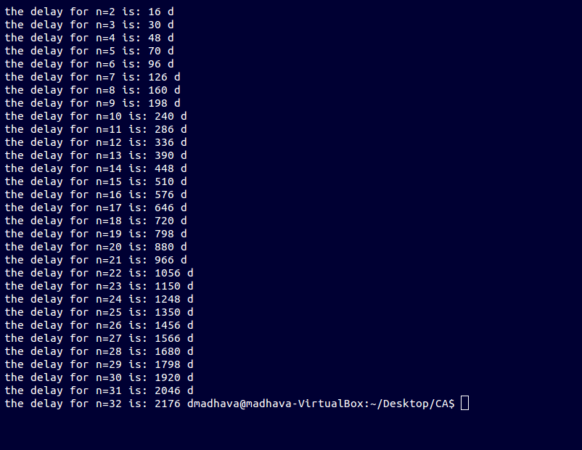

//program for shift over 0 and 1 asynchronous multiplier

#include<stdio.h>

#include<stdlib.h>

int main()

{

int a[100],a_prime[100],a_neg[100],b[100],partial_product[100],partial_product_inv[100],carry[100],c1[100],c0[100],c1_next[100],c0_next[100];

int n,test,delay,p,q,r,s,t,x,y,z,i,j,l;

int sum,average;

b[100]=0;

for(n=2;n<=32;n++)

{

sum=0;

for(test=1;test<=10000;test++)

{

for( p=0;p<=32;p++)

{

a[p]=0;a_neg[p]=0;b[p]=0;partial_product[p]=0;partial_product_inv[p]=0;c1[p]=0;c0[p]=0;c1_next[p]=0;c0_next[p]=0;

}

for(q=32;q>(32-n);q--)

{

a[q] = rand()%2;

b[q] = rand()%2;

a_prime[q] = 1-a[q];

partial_product[q]=0;

}

delay=0;

for(r=32;r>(32-n);r--)

{

delay=delay+2;

if((b[r]==0 && b[r+1]==0)||(b[r]==1 && b[r+1]==1))

{

for(s=0;s<=32;s++)

{

partial_product[s]=partial_product[s+1];

}

delay=delay+2;

delay=delay+2;

}

else if(b[r]==1 && b[r+1]==0)

{

for(t=1;t<=1;t++)

{

delay=delay+2;

c1[32]=0;

c0[32]=1;

for(x=31;x>=0;x--)

{

c0[x]=0;

c1[x]=0;

}

for(x=32;x>=0;x--)

{

partial_product_inv[x]=1-partial_product[x];

a_neg[x]=1-a_prime[x];

}

repeat:

for(y=31;y>=0;y--)

{

c0_next[y]=(a_neg[y]&partial_product_inv[y])|(c0[y+1]&(a_prime[y]^partial_product[y]));

c1_next[y]=(a_prime[y]&partial_product[y])|(c1[y+1]&(a_prime[y]^partial_product[y]));

}

for(z=31;z>=0;z--)

{

c0[z]=c0_next[z];

c1[z]=c1_next[z];

}

for(i=32;i>=0;i--)

{

if(c0[i]==0 & c1[i]==0)

{

delay=delay+2;

goto repeat;

}

}

carry[33]=0;

for(j=32;j>=0;j--)

{

carry[j]=(a_prime[j]&partial_product[j])|(a_prime[j]&carry[j+1])|(b[j]&carry[j+1]);

partial_product[j]=a_prime[j]^partial_product[j]^carry[j+1];

}

}

for(l=0;l<=32;l++)

{

partial_product[l]=partial_product[l+1];

}

delay=delay+2;

delay=delay+2;

}

else if(b[r]==0 && b[r+1]==1)

{

for(t=1;t<=1;t++)

{

delay=delay+2;

c1[32]=0;

c0[32]=1;

for(x=31;x>=0;x--)

{

c0[x]=0;

c1[x]=0;

}

for(x=32;x>=0;x--)

{

partial_product_inv[x]=1-partial_product[x];

a_neg[x]=1-a[x];

}

loop:

for(y=31;y>=0;y--)

{

c0_next[y]=(a_neg[y]&partial_product_inv[y])|(c0[y+1]&(a[y]^partial_product[y]));

c1_next[y]=(a[y]&partial_product[y])|(c1[y+1]&(a[y]^partial_product[y]));

}

for(z=31;z>=0;z--)

{

c0[z]=c0_next[z];

c1[z]=c1_next[z];

}

for(i=32;i>=0;i--)

{

if(c0[i]==0 & c1[i]==0)

{

delay=delay+2;

goto loop;

}

}

carry[33]=0;

for(j=32;j>=0;j--)

{

carry[j]=(a[j]&partial_product[j])|(a[j]&carry[j+1])|(b[j]&carry[j+1]);

partial_product[j]=a[j]^partial_product[j]^carry[j+1];

}

}

for(l=0;l<=32;l++)

{

partial_product[l]=partial_product[l+1];

}

delay=delay+2;

delay=delay+2;

delay=delay+2;

}

}

sum=sum+delay;

}

//printf("\n the final sum delay of the multiplier for n= %d is %d d",n,sum,"\n");

average=(sum/10000);

printf("\n the avg delay for the skip over asynchronous multiplier is n= %d is %d d",n,average,"\n");

}

return 0;

}

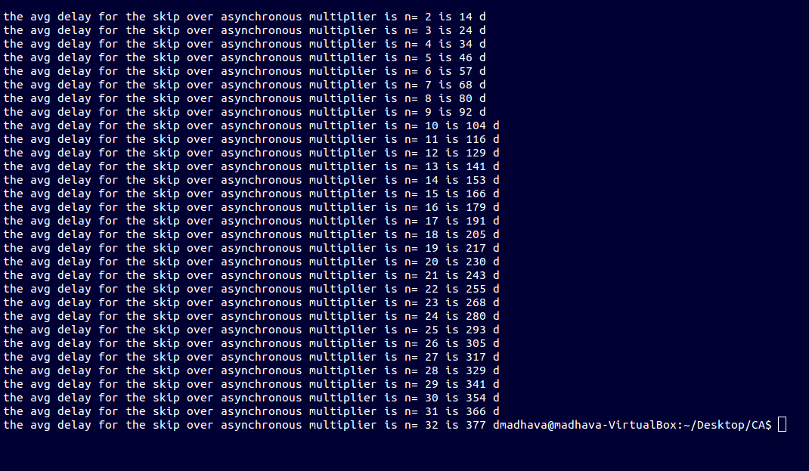

//program to multiply X4b7 and X6c9

#include<stdio.h>

#include<stdlib.h>

int main()

{

int a[33];int a_prime[33];int a_neg[33];int b[33];int partial_product[33];int partial_product_inv[33];int carry[33];b[33]=0;int c0[33];int c1[33];int c0_next[33];int c1_next[33];

a[32]=1;a[31]=1;a[30]=1;a[29]=0;a[28]=1;a[27]=1;a[26]=0;a[25]=1;a[24]=0;a[23]=0;a[22]=1;a[21]=0;

b[32]=1;b[31]=0;b[30]=0;b[29]=1;b[28]=0;b[27]=0;b[26]=1;b[25]=1;b[24]=0;b[23]=1;b[22]=1;a[21]=0;

a_prime[32]=1;a_prime[31]=0;a_prime[30]=0;a_prime[29]=1;a_prime[28]=0;a_prime[27]=0;a_prime[26]=1;a_prime[25]=0;a_prime[24]=1;a_prime[23]=1;a_prime[22]=0;a_prime[21]=1;

for(int n=12;n<=12;n++)

{

for(int m=32;m>(32-n);m--)

{

partial_product[m]=0;

}

int delay=0;

for(int i=32;i>(32-n);i--)

{

printf("\n\n\ni=%d",i);

printf("\nb[i]=%d,b[i+1]=%d",b[i],b[i+1]);

delay=delay+2;

printf("\n 2d for Multiplexer");

if((b[i]==0 && b[i+1]==0)||(b[i]==1 && b[i+1]==1))

{

for(int y=32;y<=21;y--)

{

partial_product[y]=partial_product[y+1];

}

delay=delay+2;

delay=delay+2;

}

else if((b[i]==1) & (b[i+1]==0))

{

for(int j=1;j<=1;j++)

{

delay=delay+2;

printf("\n 2d minimum delay for CCA");

c1[32]=0;

c0[32]=1;

for(int k=31;k>=0;k--)

{

c0[k]=0;

c1[k]=0;

}

for(int s=32;s>=0;s--)

{

partial_product_inv[s]=1-partial_product[s];

a_neg[s]=1-a_prime[s];

}

loop:

for(int l=31;l>=0;l--)

{

c0_next[l]=(a_neg[l]&partial_product_inv[l])|(c0[l+1]&(a_prime[l]^partial_product[l]));

c1_next[l]=(a_prime[l]&partial_product[l])|(c1[l+1]&(a_prime[l]^partial_product[l]));

}

for(int m=31;m>=0;m--)

{

c0[m]=c0_next[m];

c1[m]=c1_next[m];

}

for(int n=32;n>=0;n--)

{

if(c0[n]==0&c1[n]==0)

{

delay=delay+2;

printf("\n 2d delay for CCA(+A)");

goto loop;

}

}

carry[33]=0;

for(int m=32;m>=0;m--)

{

carry[m]=(a_prime[m]&partial_product[m])|(a_prime[m]&carry[m+1])|(b[m]&carry[m+1]);

partial_product[m]=a_prime[m]^partial_product[m]^carry[m+1];

}

}

for(int p=0;p<=32;p++)

{

partial_product[p]=partial_product[p+1];

}

delay+=2;

printf("\n 2d delay for shift");

delay+=2;

printf("\n 2d delay for triggering");

}

else if(b[i]==0 && b[i+1]==1)

{

{

for(int j=1;j<=1;j++)

{

delay=delay+2;

printf("\n 2d for CCA(-A)");

c1[32]=0;

c0[32]=1;

for(int k=31;k>=0;k--)

{

c0[k]=0;

c1[k]=0;

}

for(int k=32;k>=0;k--)

{

partial_product_inv[k]=1-partial_product[k];

a_neg[k]=1-a[k];

}

loop2:

for(int l=31;l>=0;l--)

{

c0_next[l]=(a_neg[l]&partial_product_inv[l])|(c0[l+1]&(a[l]^partial_product[l]));

c1_next[l]=(a[l]&partial_product[l])|(c1[l+1]&(a[l]^partial_product[l]));

}

for(int m=31;m>=0;m--)

{

c0[m]=c0_next[m];

c1[m]=c1_next[m];

}

for(int n=32;n>=0;n--)

{

if(c0[n]==0&c1[n]==0)

{

delay=delay+2;

printf("\n 2d delay for CCA carry not completed");

goto loop2;

}

}

carry[33]=0;

for(int m;m>=0;m--)

{

carry[m]=(a[m]&partial_product[m])|(a[m]&carry[m+1])|(b[m]&carry[m+1]);

partial_product[m]=a[m]^partial_product[m]^carry[m+1];

}

}

for(int p=0;p<=32;p++)

{

partial_product[p]=partial_product[p+1];

}

delay+=2;

printf("\n 2d delay for shift");

delay+=2;

printf("\n 2d delay for triggering");

}

}

printf("\n the delay for skip over multiplier for n= %d is %d d",n,delay,"\n");

}

}

}

